|  |  |  |  |  |  |
| --- | --- | --- | --- | --- | --- |
|  | | | Chair  Nick Paxman  Tel: 07834128598  Email: [nick.paxman@lunevalleyhousing.co.uk](mailto:nick.paxman@lunevalleyhousing.co.uk) | | |
| Our Ref: | LVRHA Recruitment | Contact: | Nick Paxman | Ext: |  |
| Your Ref: |  | **Date:** | 27th November 2024 | | |

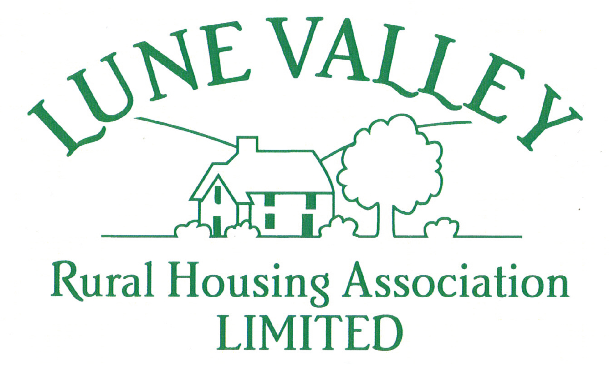

**Join Our Mission to Provide Quality Rural Homes!**

We are excited to announce an opportunity to join the Board of Directors at Lune Valley Rural Housing Association. We are on a mission to provide quality rural homes and excellent services, addressing the local rural housing crisis and ensuring our homes are safe and energy efficient.

We are looking for passionate individuals who share our commitment to teamwork and social purpose. Previous experience is not essential; what matters most is your alignment with our values and your dedication to making a difference.

We can provide support and training to aid you in the role of a Board director and ensure your time with the Board is successful. Equality, Diversity, and Inclusion are central to everything we do, and we proactively seek people to join us from all backgrounds, we are particularly keen to increase a female presence on the Board.

**Why Join Us?**

* **Impactful Work:** Contribute to meaningful projects that improve rural housing and community well-being.
* **Collaborative Environment:** Be part of a team that values every member's input and works together towards common goals.
* **Social Purpose:** Help us drive initiatives that ensure safe, energy-efficient homes for all.
* **Personal Growth:** Gain valuable experience and develop your skills in a supportive setting.

**Next Steps:**

If you are interested in joining our Board and making a positive impact, please contact the Chair Nick Paxman [nick.paxman@lunevalleyruralhousing.co.uk](mailto:nick.paxman@lunevalleyruralhousing.co.uk) or give him a call at 07834128598

Thank you for considering this role. We look forward to the possibility of working together to achieve our mission.

Warm regards,

Nick Paxman

Chair  
Lune Valley Rural Housing Association

[www.lunevallyhousing.co.uk](http://www.lunevallyhousing.co.uk)